Combining sample and census data in small area estimates: Iterative Proportional Fitting with standard software

Ludi Simpson and Mark Tranmer
Cathie Marsh Centre for Census and Survey Research, University of Manchester, M13 9PL, UK.
ludi.simpson@man.ac.uk

To be published in The Professional Geographer: this final version submitted November 28th 2003

Abstract
The combination of detailed sample data with less detailed but fully enumerated marginal sub-totals is the focus of a wide range of research. In this paper we advocate careful modelling of sample data, followed by Iterative Proportional Fitting. The modelling aims to accurately estimate the interaction or odds ratios of complex tables, which is information not contained in the marginal sub-totals. Iterative Proportional Fitting ensures consistency with the sub-totals. We advance this work in three practical ways. First, we show that detailed small area estimates of both counts and proportional distributions usually gain accuracy by combining data for larger areas containing the small areas, and illustrate the multilevel framework to achieve these estimates. Second, we find that a general classification or socio-economic typology of the small areas is even more associated with the within-area interactions than is membership of the larger area. Third, we show how the Statistical Package for the Social Sciences (SPSS) can be used for Iterative Proportional Fitting in any number of dimensions and with any structure of constraining marginal sub-totals. Throughout we use an example taken from the 1991 UK Census. These data allow us to evaluate various methods combining 100% tabulations and the Samples of Anonymised Records.

Key words: Small areas, iterative proportional fitting, multilevel models

1. Introduction

The common problem which we address is how best to estimate a detailed relationship represented by a multidimensional table, when relatively unreliable information for the cells of that table is supplemented by sub-totals which are more reliable. This situation often arises in demographic and geographical studies, and has been tackled often using Iterative Proportional Fitting (IPF). For example, when updating commuting analyses, detailed matrices of flows between origins and destinations will be approximate for years after their collection; they can be made consistent with the changing pattern of total commuters or migrants in each area that is more closely monitored (Bruton, 1985). Similarly, migration data from the US Census is insufficiently detailed for multi-dimensional demographic models, but the detailed data can be estimated from combining alternative sources with the sub-totals that are published from the census (Rogers et al., 2003). The sex and age structure for small populations may be made more certain by making initial estimates consistent with more reliable data both for the total population of the smaller areas and for the age composition of larger areas (Myers, 1992; Rees, 1994; Simpson, 1998). Sample survey data insufficient for the accurate estimation of local relationships may be supplemented with ancillary data from a census or administrative sources that give accurate sub-totals (Skinner 1991; Longford 1999; Wong, 1992, Johnston and Pattie, 1993).

We have previously discussed the extension of census data released for sub-national areas by using the additional detailed relationships available only from sample census data for the same areas (Tranmer et al., 2003). That paper explains and evaluates several statistical approaches, including multilevel modelling in order to incorporate relevant data from areas other than that being estimated. Here we extend the problem to the use of sample data for areas larger than the small areas of interest. We are interested in seeing how estimates for small areas behave when scaled to known marginal subtotals. We wish to answer the following questions: do approaches found to give the best results for large areas also give the best results for smaller areas? How good are the estimates from each approach? Moreover, this paper goes into considerable detail to explain how the common multi-dimensional scaling procedure Iterative Proportional Fitting (IPF) may be applied using appropriate SPSS commands. We explain how IPF may be applied across any number of dimensions. Hence this paper describes a novel approach that a researcher may use to carry out IPF analysis using standard statistical software. In addition we derive some useful empirical results relevant to small area estimation using this procedure, allowing us to recommend the best approach to use.

In section 2, we review the derivation of small area estimates of multi-dimensional tables from sample data, including the advantages of a multilevel modelling framework for such estimates. We use Iterative Proportional Fitting (IPF) to constrain those initial estimates to less detailed aggregate data, the marginal sub-total. Using data for England and Wales from the 1991 Census of Great Britain described in section 3, our results in section 4 show that the marginal constraints usually improve the accuracy of the estimates by ensuring consistency with information known reliably about each area. The level of accuracy is dependent on an appropriate estimation of the interaction, which is not informed by the constraining marginal data.

When the sample data are sparse within the area to be estimated, or not identified at all for that area, good estimates can nonetheless be achieved when the area is associated with a set of similar areas, for which the sample is large enough to be accurate. We estimate electoral ward areas of population 1,000 to 15,000 using marginal sub-totals for each ward and detailed relationships drawn from a national sample. The sample has geographical identifiers only for large areas containing the ward but also classifies the type of ward. In section 5 we show in detail how the IPF procedure can be flexibly implemented in SPSS, thus overcoming the limits of previous literature on the procedure which handle two-dimensional tables in special software. IPF for multiway tables for ten thousand areas is achieved in less than ten seconds in SPSS, and this aspect is likely to be of value in a great variety of applications.

2. Methods

We seek the best method of estimating spatial heterogeneity: a relationship varies between local relationships areas, but we do not have full information on that relationship. In his book ‘A solution to the ecological fallacy’, King (1997) (pages 12 ff, section 1.2; tables 1.1, 1.2) uses an example based on votes by each ethnic group to illustrate the ecological analysis problem he wishes to solve. Using two tables he first describes the aggregate data he has at district level and then at precinct level. In each of these two example tables, King puts a question mark in each cell to indicate he has no information on the cell counts; the data he has are only the aggregate margins of the table. This differs from our situation, where we have some information about the cell counts from a sample, as well as aggregate table margins from the 100% census counts. This situation, involving aggregate data plus a sample of individual data for the same area which may be linked at some geographical area level, is the one we consider here, involving the use of Iterative Proportional Fitting (IPF). King uses other techniques, based on the method of bounds rather than IPF, to develop his solution, and King’s work also assumes aggregate data only as opposed to our situation where aggregate data based on all people is combined with a sample of individual data.

We begin with the main example used in this paper, the estimation of a two dimensional table of car ownership by tenure, for which examples are given in Table 1(a). This cross-classification is available for all areas from the released Census data, which allows us to examine the accuracy of a variety of strategies for estimating the table were it not available. This will be helpful for choosing appropriate strategies for estimating tables that are truly not available from census output.
Table 1. Car ownership and tenure, national and 2 Districts
(a) True values
England and Wales | Owner-occupiers | Privately rented | Socially rented | All tenures | Odds ratio:  Socially rented/ owner-occupiers
No car | 4,456,806 | 1,367,440 | 6,046,785 | 11,871,031
 | 12.8% | 35.4% | 59.0% | 24.2%
Car | 30,389,314 | 2,499,284 | 4,206,901 | 37,095,499
All people | 34,846,120 | 3,866,724 | 10,253,686 | 48,966,530 | 9.8
Bradford | Owner-occupiers | Privately rented | Socially rented | All tenures
No car | 75,386 | 16,839 | 56,304 | 148,529
 | 21.9% | 52.4% | 75.7% | 33.0%
Car | 268,524 | 15,313 | 18,085 | 301,922
All people | 343,910 | 32,152 | 74,389 | 450,451 | 11.1
Isle of Wight | Owner-occupiers | Privately rented | Socially rented | All tenures
No car | 14,256 | 3,775 | 6,822 | 24,853
 | 14.7% | 38.3% | 54.2% | 20.8%
Car | 82,895 | 6,093 | 5,760 | 94,748
All people | 97,151 | 9,868 | 12,582 | 119,601 | 6.9

(b) National interaction constrained with IPF to District margins
Bradford | Owner-occupiers | Privately rented | Socially rented | All tenures | Odds ratio:  Socially rented/ owner-occupiers
No car | 76,934 | 16,658 | 54,937 | 148,529
 | 22.4% | 51.8% | 73.9% | 33.0%
Car | 266,976 | 15,494 | 19,452 | 301,922
All people | 343,910 | 32,152 | 74,389 | 450,451 | 9.8
Isle of Wight | Owner-occupiers | Privately rented | Socially rented | All tenures
No car | 13,456 | 3,700 | 7,697 | 24,853
 | 13.9% | 37.5% | 61.2% | 20.8%
Car | 83,695 | 6,168 | 4,885 | 94,748
All people | 97,151 | 9,868 | 12,582 | 119,601 | 9.8

In both the national and local data, car ownership varies between tenure categories: the lack of a car is generally more evident for those in socially rented accommodation (rented from the local authority or housing association). Thus an assumption of independence of tenure and car ownership will give poor estimates of the true relationship. However, there is spatial heterogeneity. The true relationship varies between areas: the lack of car ownership for socially rented households is more striking for Bradford than for the Isle of Wight. The odds ratios reflect this difference, being higher for Bradford. The odds ratios of Table 1 are calculated from the numbers in the cells as follows: the ratio of non-car owners to car owners for those in socially rented accommodation, divided by the same ratio for owner-occupiers. For example using the data in Table 1 for England and Wales, we can derive the odds ratio for car ownership for owner occupiers, compared with social renters as:
(30,389,314 / 4,456,806) / (4,205,901 / 6,046,785) = 9.8
In other words, owner occupiers are 9.8 times more likely to own a car than social renters.

Were the internal cells for the subnational areas not known, the national odds ratios for car ownership could be used in their place, but would be inaccurate. Constraining the national table of car ownership by tenure to the marginal sub-totals for car ownership and for tenure for each local area improves the estimates of car ownership for each area. This is achieved in Table 1(b) by IPF, known elsewhere as ‘raking’, ‘rim-weighting’ or structure-preserving estimation. The IPF procedure is simple in concept, scaling the initial estimates alternately to the tenure category sub-totals and the car-ownership sub-totals until the scaled values no longer change significantly. Thus the marginal sub-totals of Table 1(b) are the same as those of Table 1(a) but the odds ratios are those of the national table. The mathematics of IPF is specified in Appendix 1, and illustrated by explicitly deriving Table 1(b). David Wong (1992) experiments with IPF to estimate the odds ratios (‘interactions’) of varying magnitude. He shows that the resulting estimates are more reliable to the extent that the sample data accurately estimates the true odds ratio. Ron Johnston and Charles Pattie (1993) show the close relationship between IPF and other statistical approaches.

In the example of Table 1, all data are derived from the full census outputs. More generally, the problem is to find an accurate estimate of the local relationship before constraining to the local marginal sub-totals. Information for the relationship will often be available from sample data that give information not only for the nation but for areas within it. However, the sample within the area of interest may be so small that sampling error outweighs the advantages of the direct estimate from that local sample. Tranmer et al. (2003) evaluated a number of different strategies for estimating the relationship between car ownership and tenure for 253 areas within England and Wales, combining in various ways sample individual data and tabular aggregates published from the 1991 census. We found that direct estimates from the sample for each local area were much more accurate than assuming the national estimate applied in every local area, but that best results were gained from a multilevel model. The multilevel estimates are based on a multilevel modelling approach, which has been well documented in the recent statistical literature (see for example Goldstein (1995); Snijders and Bosker (1999)). The application of this approach to small area estimation is described in detail in Tranmer et al. (2003). Multilevel estimation is used simply to weight the local direct sample estimate with the national estimate: the local estimate is weighted proportionally to the sample it is based on such that more reliable local estimates are used with little change while less reliable local estimates are ‘shrunk’ towards the national estimate.

As our measure of overall accuracy of the estimates from each approach we used the root mean square error (RMSE). This is derived by taking the difference between the actual and estimated frequencies for each table cell in each area, squaring the difference and summing over all cells and all areas. Squaring each difference gives greater weight to large errors. This sum is then divided by (number of cells*number of areas) to give the mean square error. The square root is then taken so that the measure can be interpreted as an average difference in the true and estimated frequency count. Thus the root mean square error will give a good general measure of the accuracy of each approach taking into account all of the table cells and areas. The most accurate approach will lead to the smallest mean square error, and if the approach perfectly predicted the true values the root mean square error would be zero; in other words there would be no difference between the true and estimated frequency counts (or proportions based on these counts). The same measure is used when assessing the accuracy of the proportion of car owners in each tenure category.

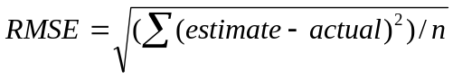

For large areas (Tranmer et al., 2003), the root mean square error of the proportion of car owners was reduced from 0.109 for the national proportion applied to all localities, to .022 for the direct estimates from local samples alone, and again to .020 for the multilevel model. In every model, constraint to the local known marginal sub-totals (using IPF as above) further improved the estimates, reducing the average error to .016 for the constrained multilevel model.

In this paper we estimate the same relationship between car ownership and tenure for all 9,363 wards of England and Wales. The Census sample individual data do not identify the ward from which each record was taken. We compare two strategies for estimating the ward relationship between car ownership and tenure, before applying IPF to make that estimated relationship consistent with marginal sub-totals known for each ward from 100% tabulations from the census. First we take the estimate of that relationship in a larger area containing the ward, as if it applied to all its wards. Second, we estimate from the sample individual data the relationship for each type of ward irrespective of its location in England and Wales.

We can summarise our research design as follows.
- We estimate the relationship between two variables, car ownership and tenure. We derive the proportion of car ownership in each tenure category from four sources:
- Assumption of no relationship: independence between car ownership and tenure.
- National data for England and Wales.
- 253 large sub-national areas, estimated directly from sample data.
- Groups of 9,363 small sub-national areas, estimated directly from sample data.
We extend the third and fourth cases by using multilevel modelling to weight the direct sample estimate and the national estimate, relying more on the national estimate when the sample for the direct estimate is small.
- The tenure-specific proportions of car ownership from each of the 4 sources and the 2 multilevel extensions are applied to the tenure totals in each area known from tabulated census data. The counts and proportions of car ownership within each tenure category are computed both for the 253 large sub-national areas and for the 9,363 small areas. The exception is that the fourth source of proportions, groups of small sub-national areas, cannot be applied to the large sub-national areas.
- We then use IPF to further scale the estimated counts to agree also with the car-ownership totals in each area, and derive new proportions from the new counts.
- We evaluate and compare each set of estimates using the root mean square error of the estimates across all small areas.

3. Data

All data are extracted from the 1991 Census, referring to England and Wales. The hierarchy of areas is as follows:
9,363 Electoral wards, average population 5,000.
253 ‘SAR areas’ of minimum population 120,000, usually a single local authority District or an amalgam of neighbouring Districts. These are the areas identified on the individual Sample of Anonymised Records.
10 Regions, for example, Yorkshire and Humberside, Inner London. These are identified on the household Sample of Anonymised Records.
The 1991 Census and its Samples of Anonymised Records (SARs) is described in detail by Angela Dale and Cathie Marsh (1993).

The marginal totals and the true cross-tabulated values are extracted from the tabulation of car ownership and tenure in Table L20 of the 1991 Census Local Base Statistics. Car ownership indicates whether or not a household has access to a car. Those renting from a local authority or a housing association are classified as ‘socially rented’, while those renting privately include properties rented with a job or business; the remaining properties are owner-occupied.

The sample data are also taken from the 1991 Census. The 2% individual SAR identifies the ‘SAR area’ from which each record has been extracted. The 1% household SAR, not overlapping with the 2% sample, has no local geographical code but identifies the region and the type of ward from which each record has been extracted.

The classification of wards has been made by the Office for National Statistics (ONS), through multidimensional scaling and cluster analysis of 37 socioeconomic, demographic, household composition, housing and employment characteristics (Wallace and Denham, 1996). The 1% SAR uses the ONS classification of wards into 14 ‘Groups’ labelled for example ‘Suburbia (Group 1)’ or ‘Deprived industrial areas (Group 14)’. Within each government region, groups with few wards have been amalgamated on the 1% SAR to ensure confidentiality, resulting in 27 categories (Dale and Openshaw, 1997). One of these categories refers only to Scotland; thus there are 26 categories of the ward classification in England and Wales.

4. Results

The strong relationship between car ownership and tenure has already been noted. An assumption of independence between the two (the same car ownership proportion in each tenure category) produces large errors averaging over 0.2 in the proportion of car owners in the 9,363 local wards (Table 2). IPF does not change these estimates. A better strategy is to apply the national (England and Wales) relationship equally to every area. This reduces the average error considerably but it remains above 0.15. Table 2 shows the average error for both the number in the six cells of the tenure by car ownership table, and for the proportion of car owners in the three tenure categories. Each will be of interest for different applications but in fact the pattern of errors is similar in the two cases. Comparative results for 253 SAR areas from Tranmer et al. (2003) are included in Table 2.

Table 2. Average error (RMSE) of estimates of the local relationship between car ownership and tenure

 | Average error of the six numbers in tenure x car-ownership cells |  |  |  | Average error of the three proportions of car owners
Nature of area: | 253 SAR areas |  | 9,363 Wards |  | 253 SAR areas |  | 9,363 Wards
Constrained to known  marginal sub-totals: | Tenure | Tenure and car | Tenure | Tenure and car | Tenure | Tenure and car | Tenure | Tenure and car
Source of relationship:
1. Independent margins | 13,490 | 13,490 | 381 | 381 | 0.213 | 0.213 | 0.209 | 0.209
2. England and Wales | 5,873 | 1,324 | 258 | 69 | 0.109 | 0.036 | 0.158 | 0.067
2% SAR, 253 SAR areas
3. Direct SAR area sample | 738 | 529 | 184 | 62 | 0.022 | 0.019 | 0.110 | 0.066
3a. Multilevel model | 686 | 467 | 184 | 61 | 0.020 | 0.016 | 0.109 | 0.065
1% SAR, 26 ward types
4. Direct Ward type sample |  |  | 146 | 57 |  |  | 0.093 | 0.063
4a. Multilevel model |  |  | 146 | 56 |  |  | 0.093 | 0.063

The average error is shown when constraining the results to only the tenure marginal sub-totals, and after using IPF to constrain to both car and tenure marginal sub-totals – known for each area from the 100% Census tabulations. It is clear that in every case IPF considerably improves the accuracy of the results. When applying the national relationship of car ownership and tenure to all areas, the additional use of IPF reduces the average error in numbers in each cell from 258 to 69, and reduces the average error in the proportion of car owners by more than half, from 0.158 to 0.067.

There are further gains when using the SAR area relationship to estimate all the wards within the SAR area. Before IPF, the average error is reduced from 0.158 to 0.110, and slightly further to 0.109 when the best multilevel SAR area estimates are used. However, after incorporating the ward marginal sub-totals the gain over using the national relationship is very little, 0.065 compared to 0.067. The marginal sub-totals capture much of the variation of car-ownership and tenure between wards, but the odds ratios still vary within a SAR area almost as much as they do within England and Wales.

Therefore the lower panel of Table 2 shows the second approach. The sample information on car ownership and tenure is grouped not within SAR areas, but across all wards of the same type, using the ONS classification of wards which is available on the 1% SAR. The classification has just 26 categories compared to the 253 SAR areas. Estimates based upon it provide a similar error to that for the estimates which use each SAR area’s estimated odds ratio for all wards within it. The average error is slightly reduced, to 0.063. The multilevel model provides no extra power as the sample in each ward classification is usually very large.

The importance of local area information is abundantly clear. The 253 SAR areas contain heterogeneous wards within them, which are equally well estimated by associating them with similar wards than with their containing SAR area. This is the case even when the ward classification takes only 26 categories and the estimates of these categories are derived from a 1% sample rather than the 2% sample used for the SAR area models.
Figure 1. Odds ratios for car ownership, contrasting social renters with owner occupiers: SAR areas and wards
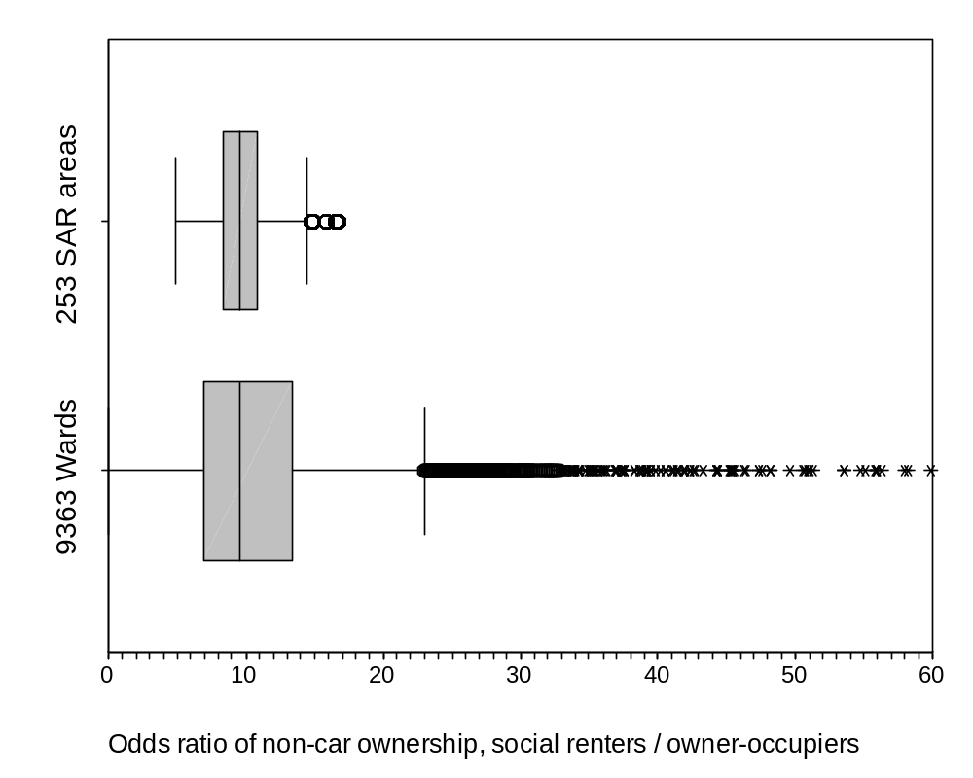
The errors reported in Table 2 are averages over all wards in England and Wales. As we saw in Table 1, the odds ratios themselves vary between SAR areas, in that case between Bradford and the Isle of Wight. Figures 1 and 2 explore the variation in odds ratios between all SAR areas, between all wards, and in the latter case between wards of different ONS classification. The odds ratio shown is the contrast between social renters and owner-occupies, when considering the odds of non-car owners to car owners. The true, recorded, figures from the Census 100% tabulations are used for these odds ratios, which vary much more between wards (standard deviation 10.0) than between Districts (standard deviation 2.1). The variation in the odds ratio between ONS classification types is considerable, explaining why its use was able to reduce the error in estimation.

It should be noted that the estimates for wards are not as good as those for SAR areas given in Table 2. The average error in the best estimates is 0.063, compared to the 0.016 achieved for SAR areas. This is caused by the lack of sample information about each specific ward. However, it is doubtful that a ward identifier on the SARs would improve these estimates, as the sample size in each ward would be extremely small for all but the largest wards.
Figure 2. Odds ratios for car ownership, contrasting social renters with owner occupiers: ward groups

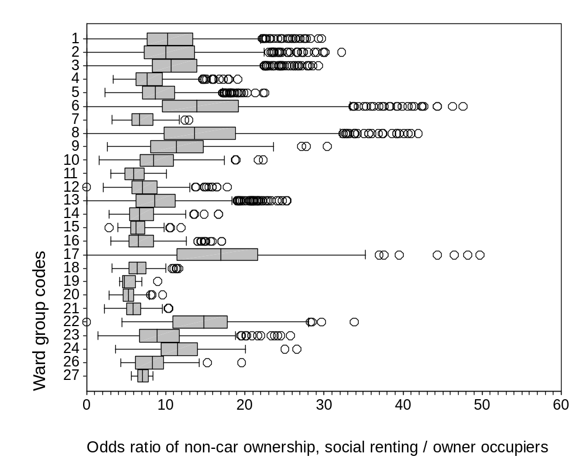
Note. Ward group code 25 is missing as it refers to wards in Scotland, not included in this study.

The errors reported in Table 2 are averages over all wards in Britain. Not all wards will show the same gain from each method, and IPF is not guaranteed to improve the estimates in every case. Proportions are unlikely to be estimated well when the marginal sub-totals are very small, and cell counts are more likely to have larger errors when the marginal sub-totals are themselves relatively large.

5. IPF implemented in SPSS

5.1 Introduction
Iterative Proportional Fitting, although it was recommended as early as 1940 (Deming and Stephan), has been included in standard statistical texts for many decades (Bishop et al., 1975) and is straightforward to compute arithmetically (see Appendix 1), is nonetheless not available as a versatile explicit routine to handle differently sized tables. Paul Norman (1999) has made available an Excel routine which implements IPF for any 2-dimensional array, but generally researchers have written their own software suited to their particular research needs as a one-off task.

However, within the Statistical Package for the Social Sciences (SPSS, 1999) there are two procedures that achieve just the estimation that is required and which are not limited to two dimensions. HILOGLINEAR and GENLOG are loglinear modelling procedures which approximate tabular data. The logarithm of each cell count predicted by the model is a linear function of parameters which are estimated from the data. For the current paper, the importance is two-fold. First, in both procedures the predicted values for a model are consistent with the observed data for the marginal sub-totals which are specified in the model. In our context, we provide observed data that are consistent with the marginal sub-totals which we wish to fix from local information. Second, a cell weight sub-command allows the ‘weight of each cell’ to be taken from a different variable; the motivation of this sub-command in the documentation is the use of zeros as cell weights in order to impose structural zeros on the model. The only mention of adjusting tables to fit margins in SPSS documentation is the comment on HILOGLINEAR to the effect that ‘You can also use CWEIGHT to adjust tables to fit new margins’ (SPSS, 1999: 536). Default initial values of 1 are used in the estimation routine (SPSS, 2003), and SPSS replaces these by the value of the cell weight variable before starting the routine. We use the CWEIGHT command and its equivalent CSTRUCTURE in GENLOG to supply the estimated cell values which we wish to be adjusted to the marginal sub-totals.

These two SPSS loglinear procedures apply to tables of any dimensions, termed ‘factors’ in SPSS documentation, and any number of categories within each factor. The table of tenure by car ownership for each of the 9363 wards of England and Wales can therefore be considered as a three-way table of dimensions 3 x 2 x 9,363. Our initial estimates fill this entire table (though many of its cells are equal when each ward from a SAR area or a ward type is given the same initial estimates). The marginal sub-totals known for each ward then comprise two two-way tables of size 3 x 9,363 (tenure by ward) and 2 x 9,363 (car ownership by ward). This approach is more efficient than the equivalent estimation of 9,363 separate 3x2 tables, each with marginal 1 x 3 and 1 x 2 marginal sub-total tables.

5.2 Preparation of data
Data should be arranged with a single record for each cell of the whole table to be estimated. The variables should include each of the factors that represent a dimension of the table, a variable containing the initial values, and a variable to represent the marginal sub-totals (see Figure 3, where the three factors are ward, car and tenure). The initial estimates may be in the form of proportions of one of the marginal factors rather than counts: IPF maintains only the odds ratios from the initial estimates, scaling them to the marginal sub-total counts. In the example in Figure 3 the initial estimates are the proportions of car owners and others within each tenure category. They have been estimated for the larger area which contains each of the three wards shown, and are therefore the same for each ward. All variables may be named for convenience by the user.

Figure 3. Example SPSS data file prepared for IPF

Ward car tenure initial margins
1 1 1 .30 183.95
1 2 1 .70 478.05
1 1 2 .54 50.30
1 2 2 .46 130.70
1 1 3 .71 79.75
1 2 3 .29 207.25
2 1 1 .30 286.31
2 2 1 .70 509.69
2 1 2 .54 87.05
2 2 2 .46 154.95
2 1 3 .71 140.64
2 2 3 .29 250.36
3 1 1 .30 85.90
3 2 1 .70 87.10
3 1 2 .54 276.56
3 2 2 .46 280.44
3 1 3 .71 135.55
3 2 3 .29 137.45

The ‘margins’ variable must contain any set of values which sum to the marginal sub-totals. One means of achieving this variable is to compute the cells of the table under the assumption that the margins are independent of each other. Many spatial data sets including UK census data are held as a single record for each area, as in Figure 4, making such a calculation straightforward. In general, for the cell referring to category i of factor 1, category j of factor 2 and so on to category k of the final factor N, multiply the overall Total by the proportion of the Total in each category. Here Margin1_{i} stands for the marginal total in category i, and so on:

Margins_{i j … k} = Total*(Margin1_{i}/Total) *(Margin2_{j}/Total)* … *(MarginN_{k}/Total)

For example the variable margins for the first record of Figure 3 – car ownership for owner-occupiers in ward 1 – was computed from the data in Figure 4 as follows:
1130*(314/1130)*(662/1130)=183.95
In this way, six extra variables are created for each record of Figure 4, each representing the variable margins for one of the six car vs. tenure categories.

Figure 4. Example Census sub-totals from which margins in Figure 3 are derived

Ward | Car=1 | Car=2 | Tenure=1 | Tenure=2 | Tenure=3 | total
1 | 314 | 816 | 662 | 181 | 287 | 1130
2 | 514 | 915 | 796 | 242 | 391 | 1429
3 | 498 | 505 | 173 | 557 | 273 | 1003

The task of manipulating the six variables derived from Figure 4 into the single variable ‘margins’ for Figure 3 was achieved in this example by saving each variable with its ward, tenure and car identifiers into six separate temporary files; the SPSS command ADD FILES was used to concatenate the six files and MATCH FILES was used to add these data to the estimates as in Figure 3.

5.3 Implementation and comparison of GENLOG and HILOGLINEAR
The records as in Figure 3 must be weighted by the variable representing marginal sub-totals. These weights are interpreted by SPSS as ‘observed’ counts in the table. Estimation of a loglinear model uses these observed data to compute expected values which add to the marginal sub-totals. Specification of a model defines which marginal sub-totals are to be taken from the observed data, while expected values for the remaining cells of the table are estimated consistent with these marginal sub-totals. The default estimation assumes no interaction (equivalently, independence) for any terms not in the model. The use of further cell weights within the loglinear procedure, equal to the initial estimates, ensures that the expected values instead retain the odds ratios represented by these initial estimates for terms not specified in the model. The SPSS terminology can be confusing in this application. The records are weighted by the margins variable, while the ‘cell weights’ within the statistical command GENLOG or HILOGLINEAR take the initial values.

In GENLOG, the initial values are given in the /CSTRUCTURE subcommand, margins are specified in the /DESIGN subcommand and the expected values are saved with variable name as specified under the /SAVE=PRED subcommand. The SPSS syntax for the file above would be as follows:

WEIGHT BY margins.
GENLOG tenure car
/CSTRUCTURE = initial /DESIGN ward*tenure ward*car
/PRINT = NONE /PLOT = NONE
/CRITERIA = CIN(95) ITERATE(20) CONVERGE(.001) DELTA(.5)
/SAVE = PRED (afteripf).
WEIGHT OFF.

The same results are achieved with procedure HILOGLINEAR as follows:

WEIGHT BY margins.
HILOGLINEAR ward (1, 3) nocar (0,1) tenure (1,3)
/CWEIGHT = initial
/PRINT = FREQ /PLOT = NONE
/CRITERIA= ITERATE(20) CONVERGE(.001) DELTA(.5)
/DESIGN ward*tenure ward*car.
WEIGHT OFF.

While the output values are the same, there are considerable differences between the two procedures which tend to favour GENLOG. In particular, GENLOG allows expected values (termed predicted values) to be saved, while HILOGLINEAR only prints expected values to the text output file in a format that is not easily exported for further use. Additionally, GENLOG accepts variables with string values and numeric values with non-consecutive values, while these must be converted to consecutive integer values by RECODE or AUTORECODE commands before using HILOGLINEAR.

However, because GENLOG is comprehensive (allowing non-hierarchical models and estimating parameters for non-saturated models, aspects irrelevant to this paper) it uses the iterative Newton-Raphson algorithm for maximum likelihood estimation. This produces the same results as IPF but is much less efficient; it requires more random memory and takes longer to reach a solution. Use of the command SPLIT FILE to repeat analyses for each local area separately, and the command SET MXMEMORY to increase the memory accessed by SPSS, enabled GENLOG to run the analyses in this paper very quickly (9,363 tenure by ward estimations for eight separate initial estimates, in under 1 minute). To prevent unnecessary output for each local area, results can be suppressed. With this strategy, HILOGLINEAR should rarely be necessary.

In some cases, the marginal sub-totals themselves may contain a zero count and this cannot be handled by GENLOG, though HILOGLINEAR correctly sets all cells within this marginal category to zero. Before running GENLOG, such cells should be set to a small count, say 0.1, and set back to zero after running GENLOG. Finally, the occurrence of zero initial estimates of proportions or counts are treated as structural zeroes. This may be unreasonable in the applied context if there are large marginal sub-totals. It is best dealt with by adding a small value, say 0.001 to these cells, which maintains their small value relative to other cells but allows non-zero estimates. The syntax incorporating these various enhancements to implement IPF for many areas is as follows:

COMPUTE margins1=margins.
IF (margins=0) margins1=0.1.
COMPUTE initial1=initial.
IF (initial=0) initial1=0.001.
SET MXMEMORY=56000.
SORT CASES BY ward tenure car.
SPLIT FILE BY ward.
WEIGHT BY margins1.
SET RESULTS OFF.
GENLOG tenure car
/CSTRUCTURE = initial1 /DESIGN ward*tenure ward*car
/PRINT = NONE /PLOT = NONE
/CRITERIA = CIN(95) ITERATE(20) CONVERGE(.001) DELTA(.0)
/SAVE = PRED (afteripf).
SET RESULTS ON.
WEIGHT OFF.
SPLIT FILE OFF.

In addition to output options, both GENLOG and HILOGLINEAR allow adjustments to default criteria for the estimation. The maximum number of iterations, the convergence criterion (how close the final results must be to the previous iteration), and the ‘delta’ value added to observed counts before estimation, may all be changed.

6. Discussion

Iterative Proportional Fitting can now be implemented generally without the need for special programs. The advantages of a multilevel modelling framework for achieving reliable initial estimates have been clarified.

Complex tables with small samples in each cell will not be well estimated by the procedures used here. However, the multilevel approach allows further modelling to account for variation between areas in order to improve small area estimates before the use of IPF. The use of the ONS classification has shown the potential for such modelling. However, at the time of writing the UK samples of anonymised records from the 2001 Census are unlikely to contain either a sub-regional identifier or a ward classification. Estimation of the type illustrated here may have to take place within the census offices or in supervised census data laboratories. As a separate development, integration of IPF within the estimation procedure would usefully provide estimates of reliability of the estimates after IPF, which are not provided here.

For census data, the specific tabulations required may be commissioned from the census database. These exact results are preferable to the estimation suggested in this paper, but may be slow, expensive or otherwise impractical to achieve. In the UK commissioned tables are not realistically available for censuses prior to 2001.

Thus both for the census and a wide variety of other applications, the need will remain to combine less reliable detailed information with more reliable aggregate sub-totals. The strategies advocated in this paper are expected to be of general and practical use.

Acknowledgements
Census data are Crown Copyright; the 1991 SARs were purchased by the UK Economic and Social Research Council and JISC for academic and other research purposes. The work for this paper and its writing were supported respectively by the UK Economic and Social Research Council awards R000223703, ‘Combining aggregate and micro-data to extend census tables for local areas’ and RR000271214, ‘Local demography and race’. Paul Norman provided helpful comments on a draft.

Appendix 1. Iterative Proportional Fitting (IPF) defined and exemplified

We first define the general iterative proportional fitting algorithm following Bishop et al. (1975, section 3.5.2), and then apply it in the two-dimensional case illustrated by Table 1 of the paper.

Take a multidimensional table with initial values m_{θ}⁽⁰⁾ of cell θ and a set of restrictions q=1, … ,s on marginal sub-totals of the table, with value x_{θq}. corresponding to cell θ. The marginal sub-total computed from the initial values is m_{θq}⁽⁰⁾.

Scale the initial values to the first marginal sub-totals to derive an estimate at step 1:
m_{θ}⁽¹⁾ = m_{θ}⁽⁰⁾ * (x_{θ1} / m_{θ1}⁽⁰⁾).
Repeat the scaling to each marginal sub-total 2, … , s to complete one cycle of s steps:
m_{θ}^{(s)} = m_{θ}^{(s-1)} * (x_{θs} / m_{θs-1}^{(s-1)}).
In general at the tth step where t-q is a multiple of s, we have:
m_{θ}^{(t)} = m_{θ}^{(t-1)} * (x_{θt-1} / m_{θq}^{(t-1)}).
At the end of the rth cycle, t=rs, compute the maximum convergence from the previous cycle:
δ^{r} = max_{θ} (abs (m_{θ}^{(rs)} - m_{θ}^{(rs-s)}).
Accept estimate m_{θ}^{(rs)} when δ^{r} is smaller than some fixed convergence criterion, for example 0.001. Since the procedure is proven to converge when the marginal sub-totals are consistent with each other (for example add to the same overall total), the choice of convergence criterion only affects the number of cycles that will be needed before the criterion is met.

For an example, Table A1 takes the national pattern of tenure and car ownership from Table 1(a), and makes it consistent with the marginal sub-totals for Bradford, also taken from Table 1(a), as was done to achieve the upper half of Table 1(b). Here there are two steps to each cycle (with two sets of marginal sub-totals, s=2). At each step, the table cells are multiplied by the ratio of one of the required margins from the Bradford data to that margin from the previous step. At each step the cell values are brought progressively more into line with the required margins, as evidenced by the reduction in maximum deviation after each cycle. The first two cycles are shown in full in table A1. The 18th step is also shown, by which time the deviation from the previous cycle is less than 0.1 and the cell values are those shown in Table 1(b). Thus nine iterations were required for this table to converge before one could be sure that integer values of the estimates would not change further.

Table A1: Illustration of Iterative Proportional Fitting to derive Table 1(b) from Table 1(a).
Step 0: initial values (England and Wales) and marginal sub-totals (Bradford) from Table 1(a)
 |  | Owner-occupiers |  | Privately rented |  | Socially rented |  |  | All tenures |  | Marginal sub-totals (Bradford)
 | No car | 4,456,806 |  | 1,367,440 |  | 6,046,785 |  |  | 11,871,031 |  | 148,529
 | Car | 30,389,314 |  | 2,499,284 |  | 4,206,901 |  |  | 37,095,499 |  | 301,922
 | All people | 34,846,120 |  | 3,866,724 |  | 10,253,686 |  |  | 48,966,530
Marginal sub-totals (Bradford) |  | 343,910 |  | 32,152 |  | 74,389 |  |  |  |  | 450,451
Step 1: scale to tenure margin
Ratio of required margin to margin at previous step |  | 0.009869 |  | 0.008315 |  | 0.007255
 |  | Owner-occupiers |  | Privately rented |  | Socially rented |  |  | All tenures
 | No car | 43,986 |  | 11,370 |  | 43,869 |  |  | 99,225
 | Car | 299,924 |  | 20,782 |  | 30,520 |  |  | 351,226
 | All people | 343,910 |  | 32,152 |  | 74,389
Step 2: scale to car margin
Ratio of required margin to margin at previous step |  | Owner-occupiers |  | Privately rented |  | Socially rented |  |  | All tenures
1.496893 | No car | 65,842 |  | 17,020 |  | 65,667 |  |  | 148,529
0.859623 | Car | 257,822 |  | 17,864 |  | 26,236 |  |  | 301,922
 | All people | 323,664 |  | 34,885 |  | 91,903
Maximum cell deviation from previous cycle (Step 0) |  |  |  |  |  |  |  | 30,131,492
Step 3: scale to tenure margin
Ratio of required margin to margin at previous step |  | 1.062553 |  | 0.921668 |  | 0.809433
 |  | Owner-occupiers |  | Privately rented |  | Socially rented |  |  | All tenures
 | No car | 69,961 |  | 15,687 |  | 53,153 |  |  | 138,801
 | Car | 273,949 |  | 16,465 |  | 21,236 |  |  | 311,650
 | All people | 343,910 |  | 32,152 |  | 74,389
Step 4: scale to car margin
Ratio of required margin to margin at previous step |  | Owner-occupiers |  | Privately rented |  | Socially rented |  |  | All tenures
1.070089 | No car | 74,864 |  | 16,786 |  | 56,878 |  |  | 148,529
0.968784 | Car | 265,397 |  | 15,951 |  | 20,573 |  |  | 301,922
 | All people | 340,262 |  | 32,738 |  | 77,452
Maximum cell deviation from previous cycle (Step 2) |  |  |  |  |  |  |  | 9022.1654
Step 18: scale to car margin
Ratio of required margin to margin at previous step |  | Owner-occupiers |  | Privately rented |  | Socially rented |  |  | All tenures
1.000000 | No car | 76,934 |  | 16,658 |  | 54,937 |  |  | 148,529
1.000000 | Car | 266,976 |  | 15,494 |  | 19,452 |  |  | 301,922
 | All people | 343,910 |  | 32,152 |  | 74,389
Maximum cell deviation from previous cycle (Step 16) |  |  |  |  |  |  |  | 0.0500
References

Bishop, YM, Fienberg, SE and Holland, PW (1975) Discrete Multivariate analysis: theory and practice. MIT Press: Cambridge USA.

Bruton MJ (1985) Introduction to Transportation Planning. London: Hutchinson.

Dale, A and Marsh, C (eds) (1993) The 1991 Census User’s Guide. HMSO: London.

Dale, A and Openshaw, S (1997) Adding Area-based Classifications to the Samples of Anonymised Records (SAR) from the 1991 Census. Centre for Census and Survey Research: Manchester.

Goldstein, H (1995) Multilevel statistical models. Halsted Press: New York.

Johnston, R and Pattie, C (1993) Entropy Maximising and the IPF procedure. Professional Geographer 45(3): 317-322

King, G (1997) A solution to the ecological inference problem. Princeton University Press: Princeton.

Longford, NT (1999) Multivariate shrinkage estimation of small area means and proportions. J Royal Statistical Society A 162(2): 227-245.

Myers, D, (1992) Analysis with local census data. Academic Press: San Diego.

Norman, P (1999) Putting Iterative Proportional Fitting on the researcher’s desk. University of Leeds Geography Department Working Paper: Leeds.

Rees, P (1994) Estimating and projecting the populations of urban communities, Environment and Planning Series A 26: 1671-97.

Rogers, A, Willekens, F and Raymer, J (2003) Imposing age and spatial structures on inadequate migration-flow datasets. Professional Geographer 55(1): 56-69.

Simpson, S (1998) Apportionment using counts of patients and electors. Pages 61-68 in Making local population statistics: a guide for practitioners, Estimating with Confidence, Simpson S. (ed). LARIA, 9 Cortland Road, Nunthorpe, Middlesbrough, TS7 0JX.

Skinner, C (1991) The use of synthetic estimation techniques to produce small area estimates. OPCS New Methodology Series NM18. London: Office for Population Censuses and Surveys.

Snijders, T and Bosker R (1999) Multilevel analysis: an introduction to basic and advanced multilevel modelling. Sage: Beverley Hills.

SPSS (1999) SPSS 10.0 syntax reference guide: base, regression models, advanced models. SPSS Inc.: Chicago.

SPSS (2003) Hiloglinear. http://www.spss.com/tech/stat/Algorithm/11.5/hiloglinear.pdf

Tranmer, M, Simpson, L, Steel D, Pickles A and Davies G (2003) Extending Census tables for local areas by combining aggregate and individual level data. Submitted for publication to the Journal of Official Statistics.

Wallace, M. and Denham, C. (1996) The ONS classification of wards. SMPS 60. (London: HMSO)

Wong, David WS (1992) The reliability of using the Iterative Proportional Fitting procedure. Professional Geographer 44(3): 340-348.

